Orientation of new members
Many members will have little training in emergency deployment. We will provide as much as we can in as little time as possible. Part of the Basic training during the CoVid19 event will be the prevention of the spread of the virus. This will include:
-Describing social distancing
-Avoiding personal contact (see below)

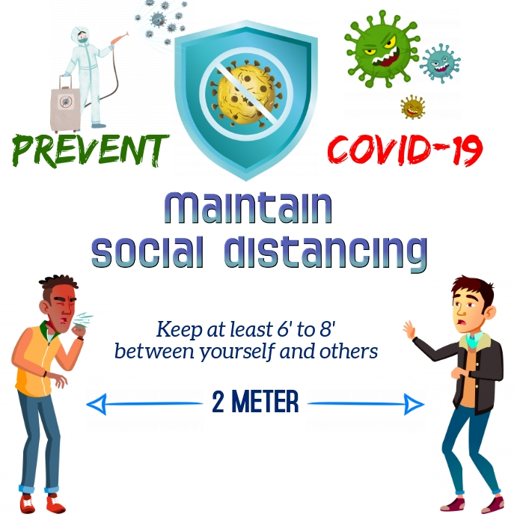

-Washing hands properly (see training video) and often

Other training and instruction will include, but not limited to:

-Proper lifting techniques for all members (see training video)
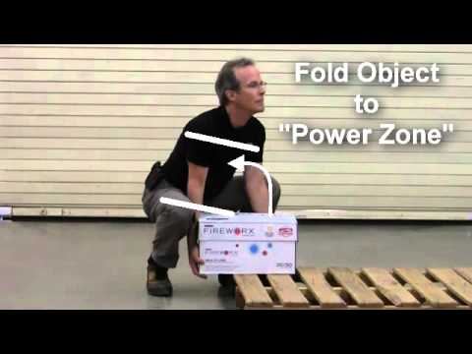

-Donning and doffing protective gloves when needed (see training video)

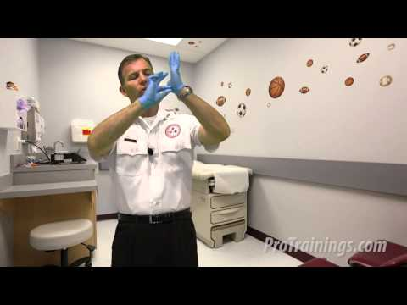

-Training in the assigned tasks

Please call (920-421-4375) or email at doorcesc@gmail.com with any additional questions.

It will be emphasized that any information concerning persons being assisted is to be considered private/personal and not to be shared outside of the confines of the team.

